You can see how Maple functions work by utilising a logfile available to the Maple Plugin.
- Press in the following order: Insert > Development Tools > Plugin’s Folder > Maple Tools.

- Click on Maple Tools, you should see something like below:

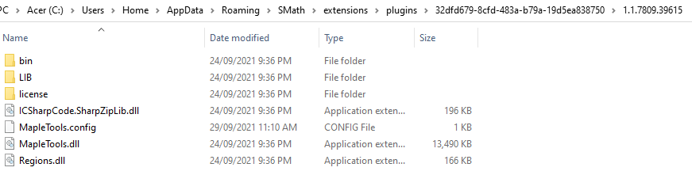

- Open up MapleTools.config with a tool such as Notepad++ or equivalent, should see something like below:
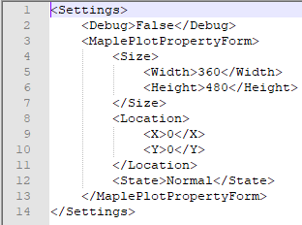

- Change False to True:
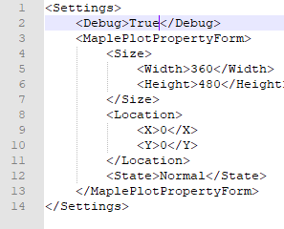

Please note, changes to MapleTools.config need to happen when  is not running.

- Now open the bin directory,
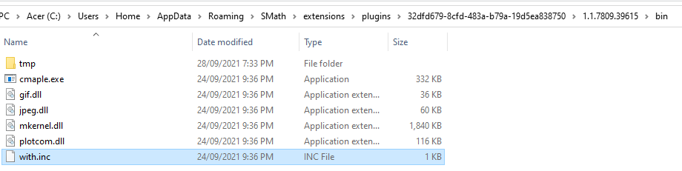

- Now look inside with.inc using Notepad++ or equivalent:
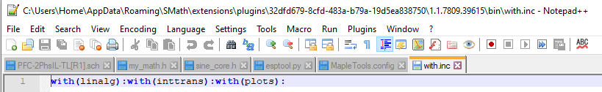

- You can add additional packages such as: combinat; combstruct; DEtools; difforms; Domains; finance; GaussInt; genfunc; geometry; grobner; group; liesymm; logic; LREtools; networks; numapprox; numtheory; orthopoly; padic; plottools; powseries; process; simplex; stats; student; sumtools; tensor; totorder.

- After running a session, you should now be able to see a log file:

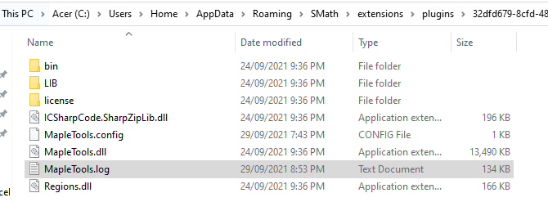

It should contain the following sort of information:
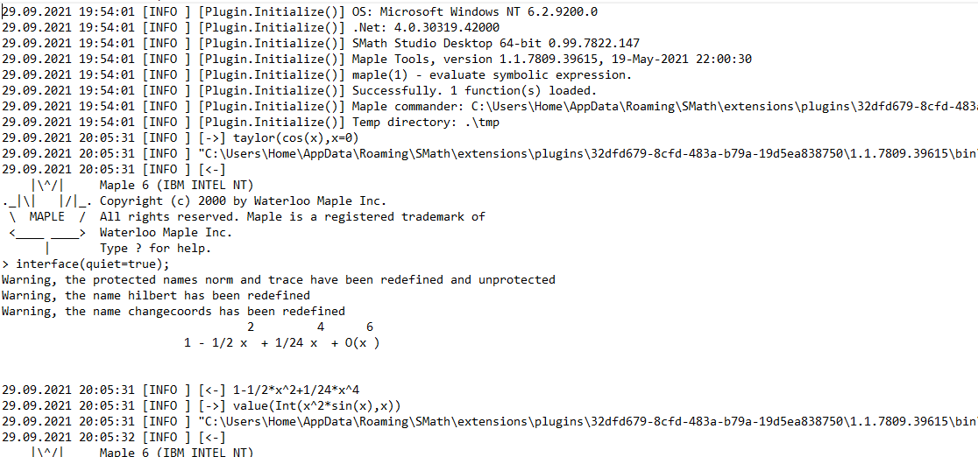

And away we go!

